|  |  |  |  |
| --- | --- | --- | --- |
| **Supplementary Material A.** Composition of parliament in the Netherlands (2017) | | | |
| **Political Party** | **social dimension** | **N / mean** | **prop. / SD** |
|  | *gender* |  |  |
| parliament | male | 96 | 0.64 |
| parliament | female | 54 | 0.36 |
| parliament | *age* | 45.13 | 9.32 |
| parliament | *minority status* |  |  |
| parliament | no visible minority | 134 | 0.89 |
| parliament | visible minority | 16 | 0.11 |
| parliament | *political party* |  |  |
| parliament | VVD: People's party for Freedom and Democracy | 33 | 0.22 |
| parliament | PVV: Party for Freedom | 20 | 0.13 |
| parliament | CDA: Christian Democratic Appeal | 19 | 0.13 |
| parliament | D66: Liberal Democrats | 19 | 0.13 |
| parliament | GroenLinks: GreenLeft | 14 | 0.09 |
| parliament | SP: Socialist Party | 14 | 0.09 |
| parliament | PvdA: Labour Party | 9 | 0.06 |
| parliament | CU: Christian Union | 5 | 0.03 |
| parliament | Partij voor de Dieren: Party for the Animals | 5 | 0.03 |
| parliament | 50Plus: 50Plus | 4 | 0.03 |
| parliament | DENK: THINK | 3 | 0.02 |
| parliament | SGP: Reformed political Party | 3 | 0.02 |
| parliament | FvD: Forum for Democracy | 2 | 0.01 |
|  | *gender* |  |  |
| VVD | male | 23 | 0.70 |
| VVD | female | 10 | 0.30 |
| PVV | male | 14 | 0.70 |
| PVV | female | 6 | 0.30 |
| CDA | male | 13 | 0.68 |
| CDA | female | 6 | 0.32 |
| D66 | male | 12 | 0.63 |
| D66 | female | 7 | 0.37 |
| GroenLinks | male | 6 | 0.43 |
| GroenLinks | female | 8 | 0.57 |
| SP | male | 9 | 0.64 |
| SP | female | 5 | 0.36 |
| PvdA | male | 4 | 0.44 |
| PvdA | female | 5 | 0.56 |
| CU | male | 3 | 0.60 |
| CU | female | 2 | 0.40 |
| PvdDieren | male | 2 | 0.40 |
| PvdDieren | female | 3 | 0.60 |
| 50Plus | male | 2 | 0.50 |
| 50Plus | female | 2 | 0.50 |
| DENK | male | 3 | 1.00 |
| SGP | male | 3 | 1.00 |
| FvD | male | 2 | 1.00 |

*Supplementary Material A. continued*

|  |  |  |  |
| --- | --- | --- | --- |
|  | *age* |  |  |
| VVD | age | 44.03 | 6.72 |
| PVV | age | 46.05 | 10.09 |
| CDA | age | 44.79 | 7.84 |
| D66 | age | 43.84 | 10.16 |
| GroenLinks | age | 47.14 | 10.08 |
| SP | age | 38.36 | 6.99 |
| PvdA | age | 44.89 | 7.99 |
| CU | age | 46.80 | 4.38 |
| PvdDieren | age | 45.20 | 8.26 |
| 50Plus | age | 64.75 | 8.02 |
| DENK | age | 42.33 | 5.51 |
| SGP | age | 52.33 | 7.57 |
| FvD | age | 53.50 | 27.58 |
|  | *minority status* |  |  |
| VVD | no visible minority | 30 | 0.91 |
| VVD | visible minority | 3 | 0.09 |
| PVV | no visible minority | 19 | 0.95 |
| PVV | visible minority | 1 | 0.05 |
| CDA | no visible minority | 18 | 0.95 |
| CDA | visible minority | 1 | 0.05 |
| D66 | no visible minority | 17 | 0.89 |
| D66 | visible minority | 2 | 0.11 |
| GroenLinks | no visible minority | 11 | 0.79 |
| GroenLinks | visible minority | 3 | 0.21 |
| SP | no visible minority | 12 | 0.86 |
| SP | visible minority | 2 | 0.14 |
| PvdA | no visible minority | 8 | 0.89 |
| PvdA | visible minority | 1 | 0.11 |
| CU | no visible minority | 5 | 1.00 |
| PvdDieren | no visible minority | 5 | 1.00 |
| 50Plus | no visible minority | 4 | 1.00 |
| DENK | visible minority | 3 | 1.00 |
| SGP | no visible minority | 3 | 1.00 |
| FvD | no visible minority | 2 | 1.00 |

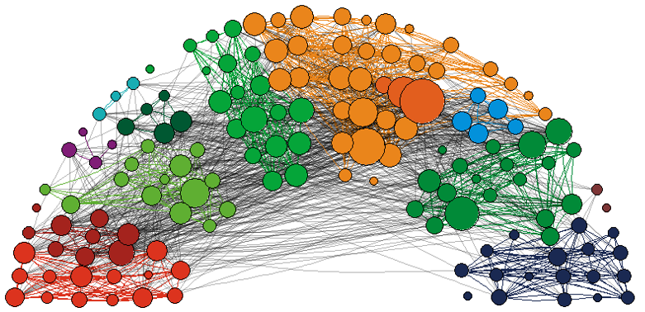

**Panel a.** Follower relations

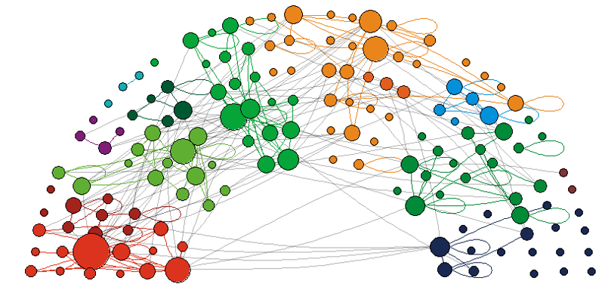

**Panel b.** @-mentions

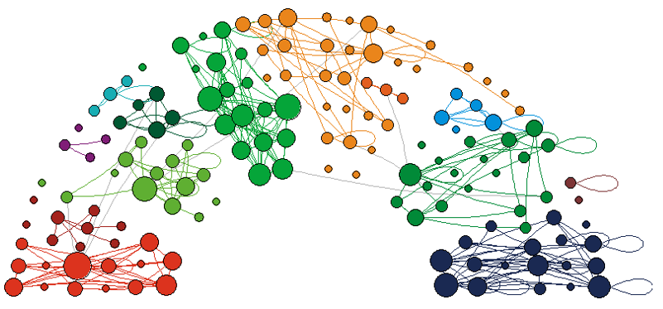

**Panel c.** Retweets

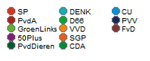

**Supplementary Material B.** Reciprocated twitter relations between Dutch MPs (2017)

*Notes: Node size based on degree. Edge color based on Party affiliation, black if MPs from different party*

|  |  |  |  |  |  |  |
| --- | --- | --- | --- | --- | --- | --- |
| **Supplementary Material C.** Multiplex RSiena model to predict twitter relations among (147) Dutch MPs in 2017: full results Model 1 | | | | | | |
|  | b | se | b | se | b | se |
|  | *following* | | *@-mentions* | | *retweets* | |
| *rate parameters* |  |  |  |  |  |  |
| period 1 (April – June) | 4.626 | 0.293 | 66.540 | 48.362 | 18.468 | 1.760 |
| period 2 (June – September) | 2.035 | 0.130 | 13.365 | 0.943 | 17.263 | 1.437 |
| *structural effects* |  |  |  |  |  |  |
| outdegree | -13.307 | 1.871 | -4.215 | 0.140 | -3.923 | 0.164 |
| reciprocity | 0.847 | 0.114 | 1.402 | 0.090 | 0.615 | 0.094 |
| transitive triplets | 0.037 | 0.007 | 0.066 | 0.036 | 0.157 | 0.025 |
| shared popularity | -0.001 | 0.000 | -0.008 | 0.010 | -0.014 | 0.005 |
| indegree - popularity (sqrt) | 0.351 | 0.062 | 0.395 | 0.051 | 0.393 | 0.045 |
| outdegree - popularity (sqrt) | -0.186 | 0.034 | -0.096 | 0.039 | -0.271 | 0.059 |
| outdegree - activity (sqrt) | 1.328 | 0.250 | 0.256 | 0.025 | 0.162 | 0.027 |
| *ego characteristics* |  |  |  |  |  |  |
| Liberal Democrats |  |  |  |  | -0.427 | 0.074 |
| Populist Radical Right |  |  |  |  | -0.180 | 0.084 |
| Green party |  |  | 0.135 | 0.070 |  |  |
| party leader |  |  | -0.300 | 0.096 |  |  |
| incumbent |  |  |  |  | -0.114 | 0.045 |
| position on election ballot | 0.542 | 0.154 |  |  |  |  |
| *alter characteristics* |  |  |  |  |  |  |
| Liberal Democrats |  |  | -0.104 | 0.071 |  |  |
| Green party |  |  | -0.171 | 0.084 |  |  |
| Incumbent | -0.507 | 0.087 |  |  | -0.082 | 0.046 |
| position on election ballot |  |  | -0.012 | 0.003 | -0.012 | 0.004 |
| party leader |  |  | 0.129 | 0.092 | 0.122 | 0.079 |
| *dyad characteristics* |  |  |  |  |  |  |
| same incumbency status | 0.165 | 0.083 |  |  |  |  |
| seating distance | -0.022 | 0.007 |  |  | -0.031 | 0.006 |
| same party | 1.083 | 0.146 | 0.918 | 0.054 | 1.386 | 0.078 |

*Notes:* Overall maximum convergence ratio: 0.2471; parameter estimates with a *t-value < 1* have been dropped.